**Order page:**

**هذه الصفحة شبيهة لموقع اكسباند كارت**

لرؤية وظائف عمل صفحة يمكنك زيارة موقع اكسباند كارت واستعمال اليوزر التالي:

<https://login.expandcart.com>

**Email**: [znairat@gmail.com](mailto:znairat@gmail.com)

**PW**: hnf89s8t

This page help users to see all orders that was created in the Estore, and the main benefit we need in this page is to help users to **create order manually** if needed and as shown in figure 1.1

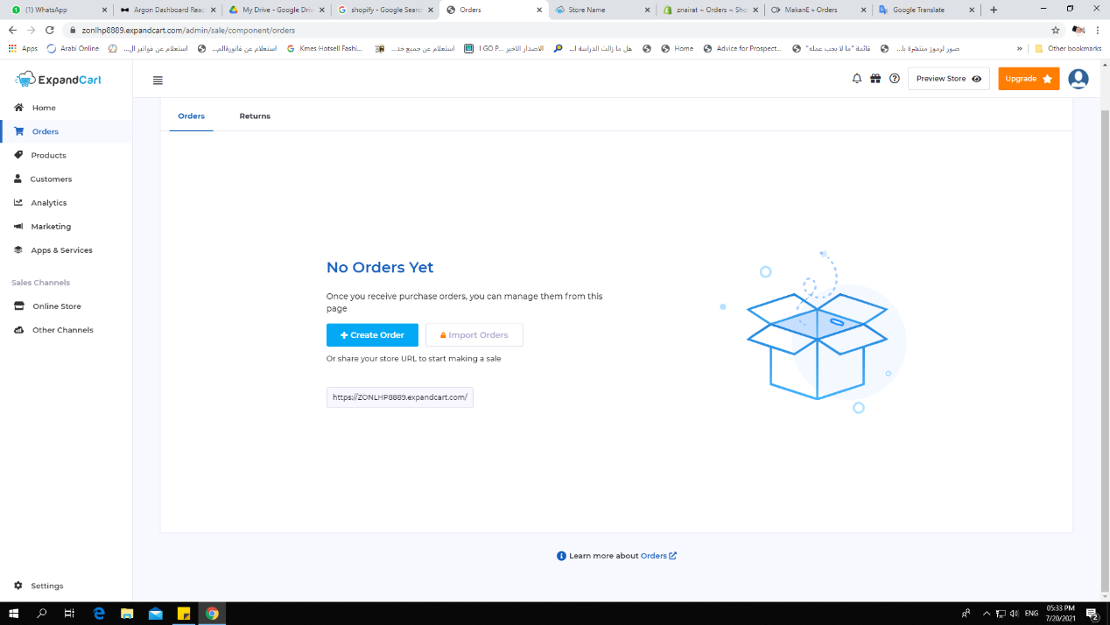

Figure 1.1

2. If there were orders in the estore the user will see the order page as figure 1.2

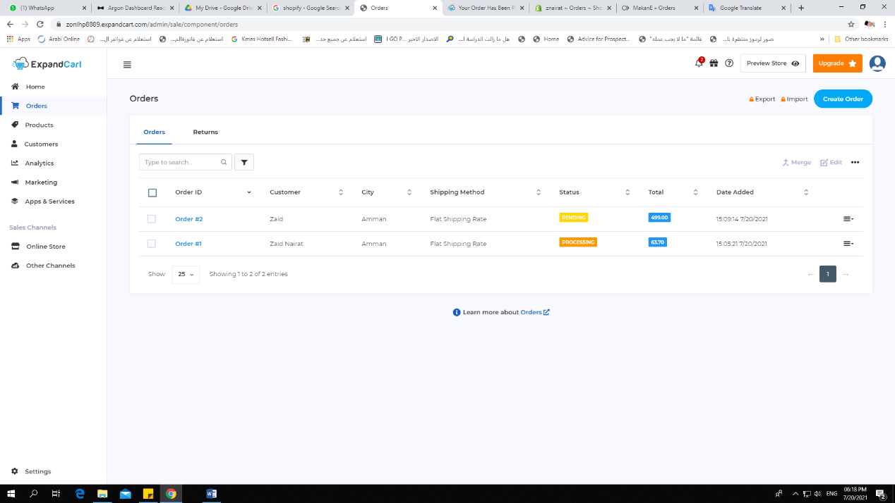

Figure 2.1

3- If the user need to create order manually in the platform he must follow this process

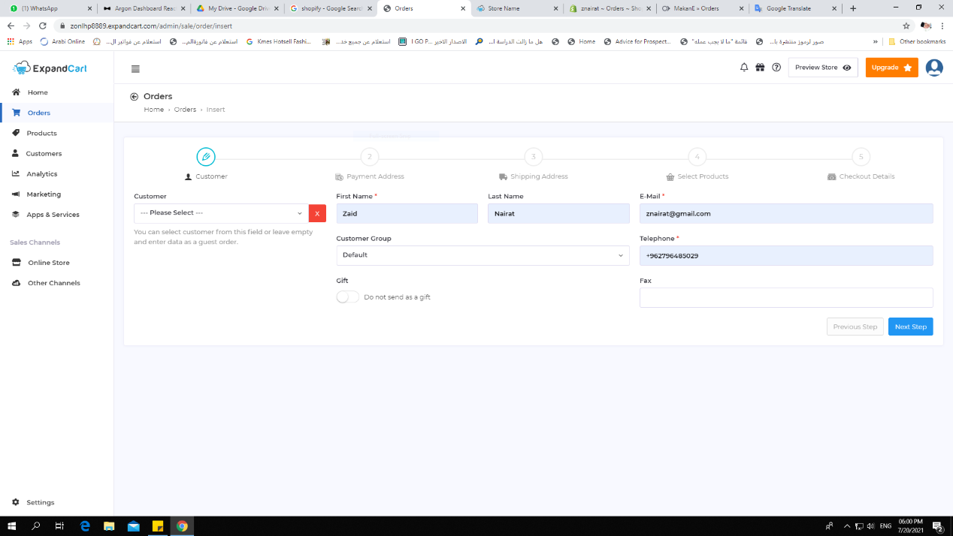

No.1: user will add customer data as step number 1 (if the customer data are already enrolled in the platform, the user will select his name and will automatically fill. If not the user will add the data manually as shown: First name, Last name and etc…)

4. this step the user will add address for his customer

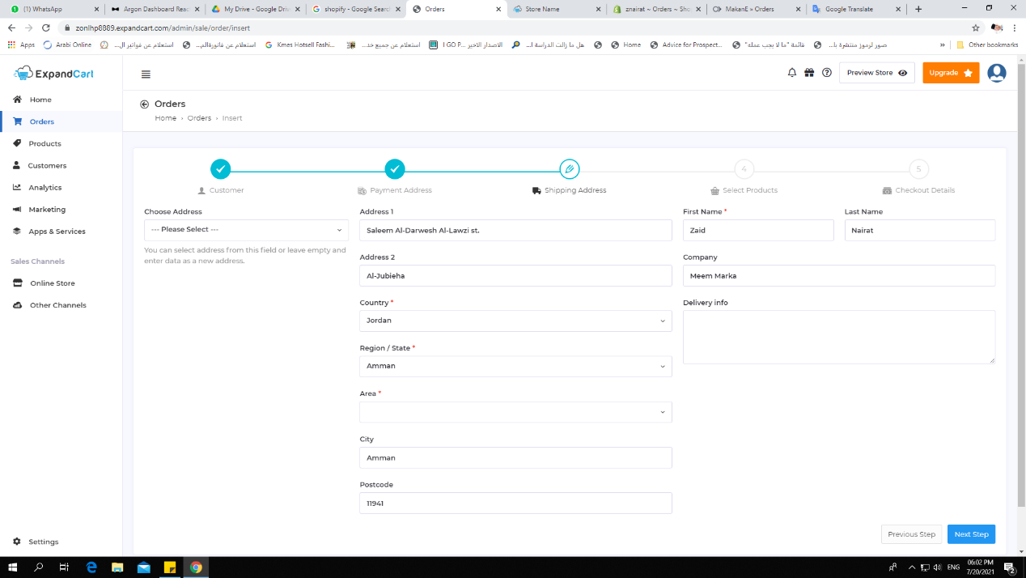

5- This step user will chose and select the item that the customer needs to purchase it includes (quantity)

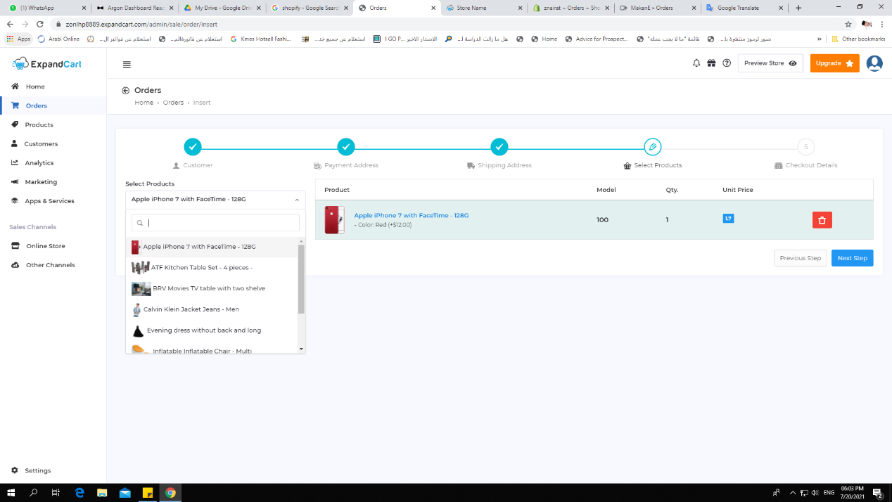

6- When the user added customer order manually, the user will enter to order page as picture below:

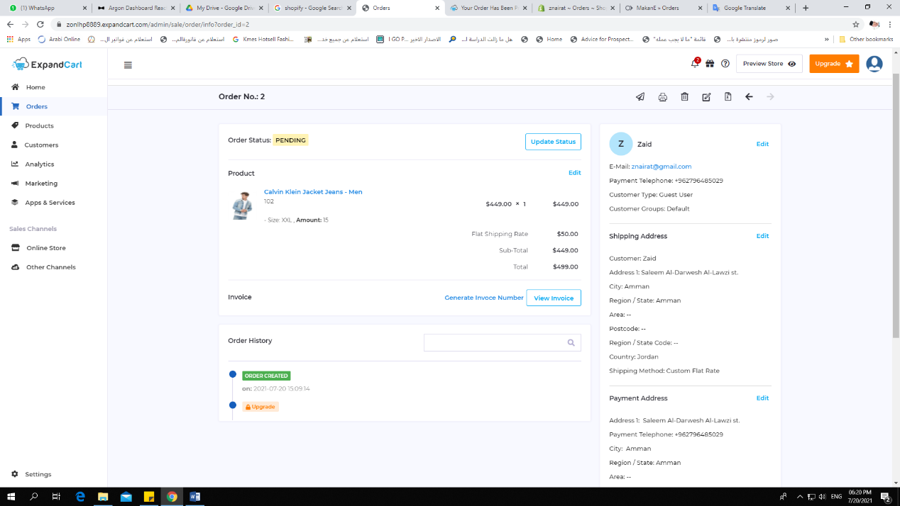

This includes all information the user added plus can update status manually if there were any updates with customer

1. User can also download the invoice from this page to stick it with delivery parcel if press **view invoice** and chose the languages as shown in the pictures

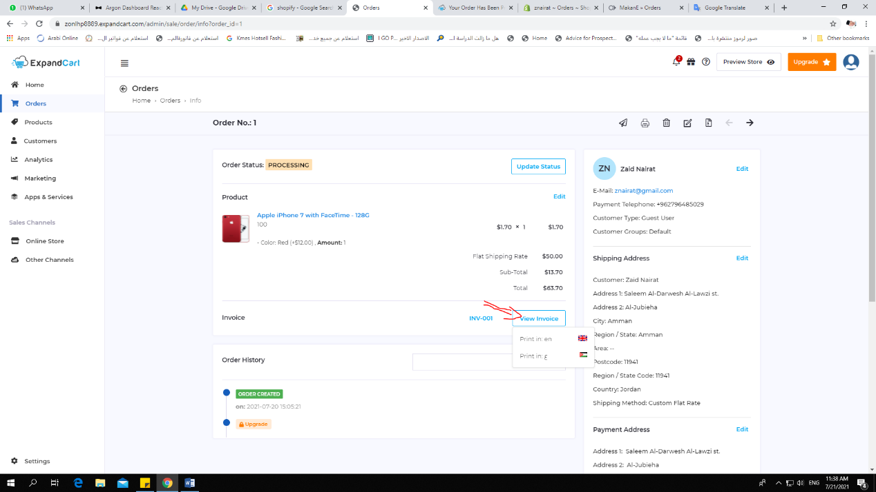

1. If user select the language that needs it will be shown as the picture below

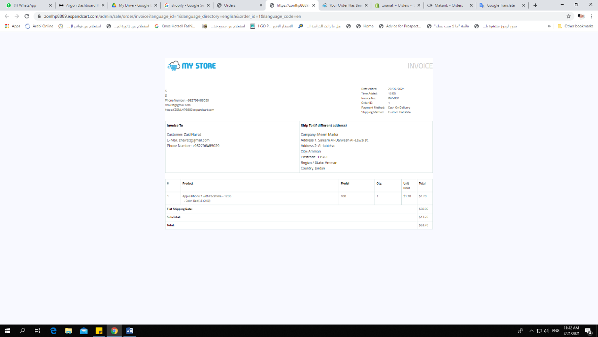

7- In the end, if user returns to order page will find all order shown as the picture below:



**Return product**

What will happen if the customer called our users and told them to return the order or 1 item because there is error or wrong items?

This page will be in the same order section and it will help user to track returns details here. For which customer the returns belong to, what product from the order was returned and reasons

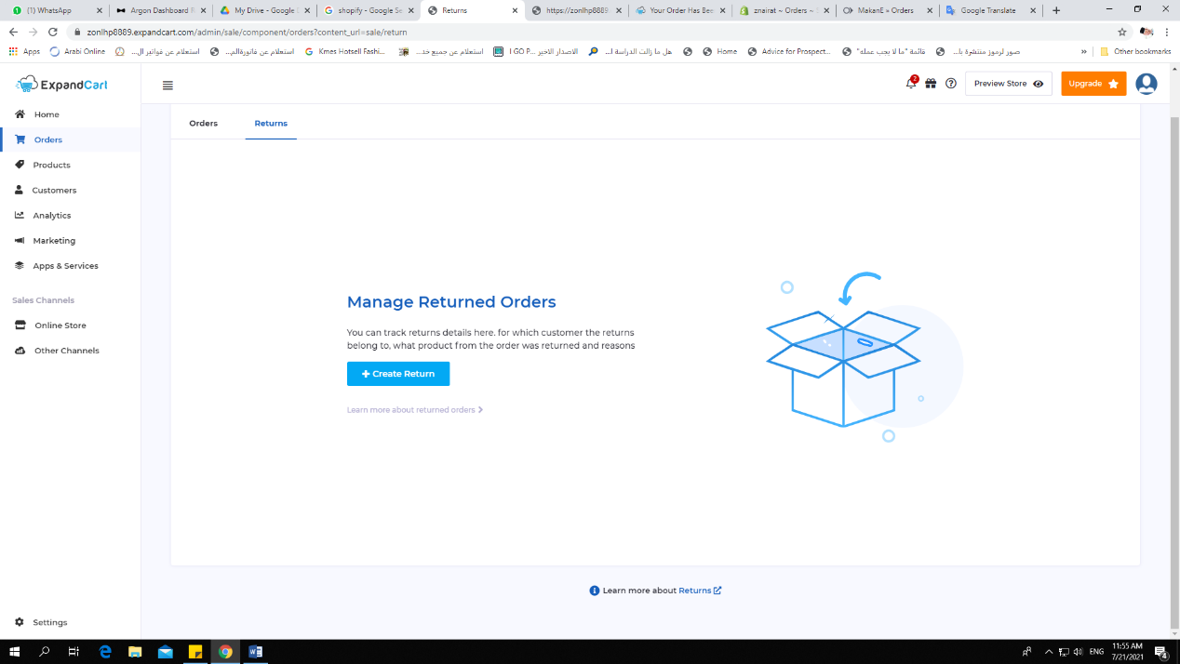

2. If the user will create return order he/she needs to enter the data as shown in the picture:

